**1) Install JDK**

* Set PATH(C:\Program Files\Java\jdkXXXX\bin),in environmental variables.
* Check java -version, javac -version

**2)Download and Install Maven**

* Set Path(C:\MVN\apache-maven-3.9.6-bin\apache-maven-3.9.6\bin)
* Check mvn -version

**3)Install IntelliJ/Eclipse/STS**

**4) Create Github account.**

**5)Basic git commands**

git clone <repository-url>

git add <file>

git add .

git commit -m "Your commit message"

git push origin <branch-name>

git checkout <branch-name> #Create a new branch.

git checkout -b <new-branch> #Switch to a different branch.

**If you face issue(permission denied) while pushing your code to repo, follow below steps**

**1. Check If You Have an SSH Key**

Run this command to check if you already have an SSH key:

ls -al ~/.ssh

If you see files like id_rsa.pub or id_ed25519.pub, you already have an SSH key. If not, you need to generate one.

**2. Generate a New SSH Key (If Needed)**

If you don’t have an SSH key, generate one with:

ssh-keygen -t ed25519 -C "your-email@example.com"

Replace "your-email@example.com" with the email associated with your GitHub account. If your system doesn’t support ed25519, use:

ssh-keygen -t rsa -b 4096 -C "your-email@example.com"

**3. Add Your SSH Key to the SSH Agent**

Start the SSH agent:

eval "$(ssh-agent -s)"

Then add your key:

ssh-add ~/.ssh/id_ed25519 # or ~/.ssh/id_rsa if using RSA

**4. Add Your SSH Key to GitHub**

Copy your public key:

cat ~/.ssh/id_ed25519.pub # or ~/.ssh/id_rsa.pub

Go to [GitHub SSH settings](https://github.com/settings/keys) and **Add New SSH Key**.

**5. Test Your Connection**

Run:

ssh -T git@github.com

If it works, you should see:

vbnet

CopyEdit

Hi <<yourusername>>! You've successfully authenticated, but GitHub does not provide shell access.

**6. Set the Correct Remote URL**

Verify your remote URL:

sh

CopyEdit

git remote -v

If it's incorrect, update it:

sh

CopyEdit

git remote set-url origin git@github.com:thetelugucoder/HelloWorldApplication.git

**7. Try Pushing Again**

Now, try pushing:

sh

CopyEdit

git push origin main # or your branch name

UML Diagrams for todo application:

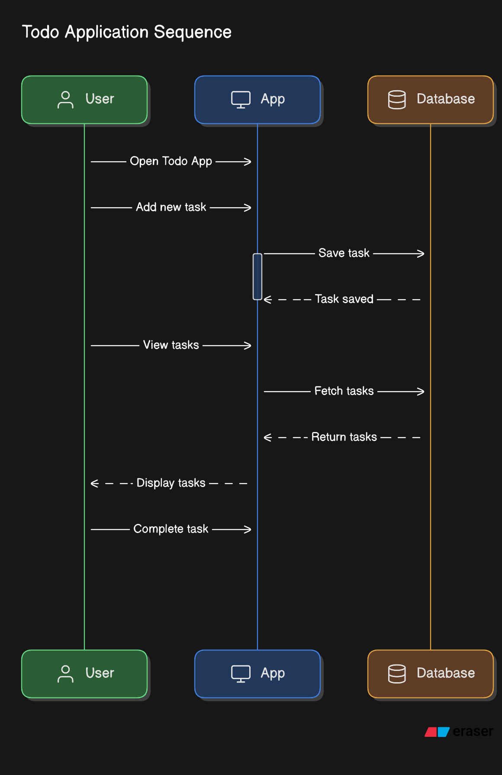

**UseCase Diagram:**

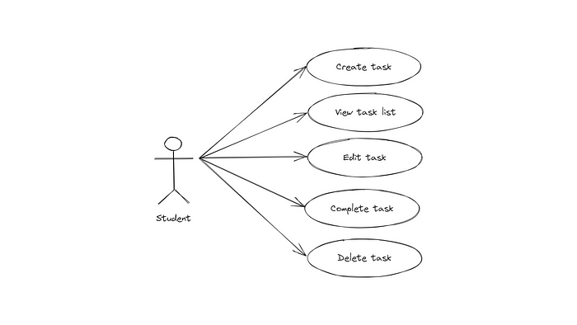

**Class Diagram:**

